بعد إذنكم يخلص نهارده عشان الديدلاين بكره 🙂 ok

البرزنتيشن بالعربي ولا بالانجليزي ؟ انجليزي

معلش كل واحد يكتب اسمه قبل الجزء بتاعه

ما تعملوا جروب تاني تلجرام جروب 1 بدل البتاع دا …. سوري كان قصدي لينكد ان
ماشي اكتبوا اليوزر نيم وهضيفكم
انا مدخلتش يوزر التليجرام

(SAJA RAFAT)

What is Communication?

-Communication is the process of sharing information, ideas, or feelings.
-It can be verbal, non-verbal, or written.
-It involves a sender and a receiver.

Why is Communication Important?
-Improves teamwork.

-Prevents misunderstandings.

-Building long-term relationships .

(Nada Ayman)

Common Barriers to Effective Communication:

What are Communication Barriers?
- Barriers are problems that block communication
- They cause misunderstanding or confusion
- They reduce clarity and effectiveness

- Use of Jargon
- Jargon means technical or difficult words
- Not everyone understands them
- Example: medical or technical terms

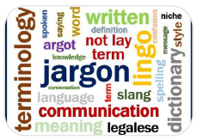
- Emotional Barriers
- Emotions like anger, stress, fear
- Can affect listening and speaking
- Lead to misunderstanding

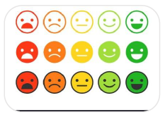
- Lack of Attention & Distractions
- Mobile phones
- Noise
- Daydreaming

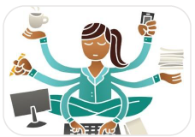

- Difference in Perception
- People think differently
- Same message, different meanings
- Based on experience and mindset
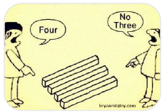

- Physical Barriers
- Noise
- Distance
- Poor environment


- Language Differences
- Different languages
- Accents
- Poor vocabulary
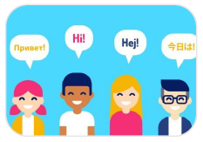
- Cultural Differences
- Different traditions and beliefs
- Different body language
- Different communication styles
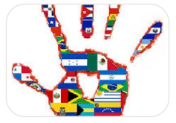
- How to Overcome Communication Barriers
- Use simple language
- Listen carefully
- Be patient and respectful
- Avoid distractions

Nehalhammam

The 7 C’s of Effective Communication الفعال للتواصل السبعة العناصر
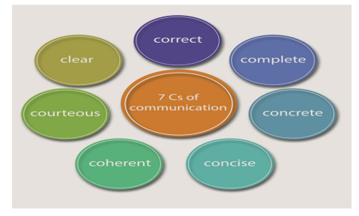
- Clear – Know your purpose and express one main idea per sentence to avoid confusion.
- Concise – Keep messages brief by removing repetition and unnecessary words.
- Concrete – Use specific facts and details so your message is easy to understand.
- Correct – Check for errors to keep communication professional and accurate.
- Coherent – Ensure all points are connected, relevant, and flow logically.
- Complete – Provide all necessary information so the audience can act or decide.
- Courteous – Maintain a polite, respectful, and positive tone.

Marwa Ashraf
What the meaning of Non-Verbal Communication?

- Non-verbal communication (NVC) is the transmission of messages without words.
- Includes gestures, facial expressions, posture, eye contact, tone, and body language.
- Studies show that over 70% of communication is non-verbal.

Types of Non-Verbal Communication
- Facial Expressions – Happiness, anger, surprise, sadness.
- Gestures – Hand movements, nods, thumbs up.
- Posture & Body Orientation – Open vs closed body language.
- Eye Contact – Interest, confidence, or avoidance.
- Paralanguage – Tone, pitch, volume, and speed of speaking.
- Proxemics – Personal space and distance.

Importance of Non-Verbal Communication
- Enhances understanding of spoken words.
- Conveys emotions and attitudes.
- Builds trust and rapport.
- Useful in professional, social, and cross-cultural settings.
Positive Non-Verbal Signals | Negative Non-Verbal Signals
Open posture (uncrossed arms/legs) | Closed posture (crossed arms/legs)
Smiling and friendly facial expressions | Frowning or scowling
Maintaining appropriate eye contact | Avoiding eye contact
Nodding to show understanding | Shaking head or ignoring cues
Leaning slightly forward (showing interest) | Leaning back or slouching
Calm and controlled gestures | Fidgeting, tapping, or restless movements
Relaxed tone of voice | Harsh, monotone, or rushed speech

Abdelrahman
Here is a redesigned, cleaner, and more professional version, still in simple English and easy to present:

Verbal Communication

Simple Presentation

1. What is Verbal Communication?
Verbal communication is using spoken words to talk to others.
We use it to share ideas, explain information, and understand people.

2. Importance of Verbal Communication
Verbal communication helps us to:
- Share ideas clearly
- Reduce misunderstandings
- Build trust and good relationships
- Work effectively with clients and team members

3. Speaking Clearly
To speak clearly, you should:
- Use simple and clear words
- Speak slowly
- Avoid difficult or technical terms
- Arrange your ideas before speaking

4. Giving Information Effectively
When giving information:
- Start with the main idea
- Add details step by step
- Use simple examples
- Speak in a friendly tone
- Ask questions to confirm understanding

5. Asking Questions
Asking questions helps you:
- Get more information
- Show interest
- Check understanding

Types of Questions:
- Open questions: need long answers
- Closed questions: yes or no answers
- Follow-up questions: clarify information

6. Tone of Voice
Tone means how you say words, not just what you say.
A good tone should be:
- Calm
- Friendly
- Respectful
A bad tone can create problems even if the words are correct.

7. Listening in Verbal Communication
Good communication needs good listening:
- Listen carefully
- Do not interrupt
- Show interest
- Understand feelings, not only words

8. Common Communication Problems
Some common problems include:
- Speaking too fast
- Using difficult words
- Poor listening
- Emotional reactions

9. Tips to Improve Verbal Communication
- Think before you speak
- Be polite and respectful
- Stay positive
- Speak and ask questions clearly
- Listen more than you talk

10. Conclusion
Verbal communication is an important skill.
By speaking clearly, listening well, and using the right tone, we can:
- Work better with others
- Build strong relationships
- Communicate with confidence

Asmaa Reda
Types of Customers Freelancers Deal With
1-The Startup Founder
Needs:
Speed, creativity, and flexibility
2- The Corporate Client
Needs:
guidelines brand with alignment ,reports ,Professionalism
3-The Project Manager
Needs:
Fast turnaround, and adherence to briefs
4-The One-Time Client
Needs:
engagement simple ,response quick ,results Immediate
5-The Repeat or Long-Term Client
Needs:
communication smooth ,support Ongoing

